**STREAMLINING TICKET ASSIGNMENT FOR EFFICIENT SUPPORT OPERATIONS**

**Team ID:** NM2025TMID1648

**Team ( Members ) Size:** 5

**Team Leader:** S Sanjay

**Team Member 1:** Arun Kumar

**Team Member 2:** prasanth

**Team Member 3:** Roshan Daniel

**Team Member 4:** azhageshan

**TEAM INITIALIZATION**

**Streamlining Ticket Assignment:**

Streamlining Ticket Assignment uses automation and predefined rules within a ticketingsystem to automatically route requests to the most appropriate agents or teams, improving efficiency by reducing manual effort, decreasing response times, increasing agentproductivity, ensuring consistent and equitable distribution of work, and enhancing customer satisfaction through faster, more accurate solution.

**Objective:**

The objective of this initiative is to implement an automated system for ticket routing at ABC Corporation, aimed at improving operational efficiency by accurately assigning support tickets to the appropriate teams. This solution aims to reduce delays in issue resolution, enhance customer satisfaction, and optimize resource utilization within the support department.

**Milestone 1: Users**

**Activity 1: Create Users**

1. The first thing we need to do to create user is to Open service now.
2. After opening Servicenow we need to Open the instance.
3. Then Click on All present in the menu bar then search for users.
4. Select Users which is present under system security.
5. After selecting Users under system security, Click on new present in the right side top of the screen.
6. The page will appear as shown below with blank spaces
7. Fill the following details given in the figure shown below to create a user.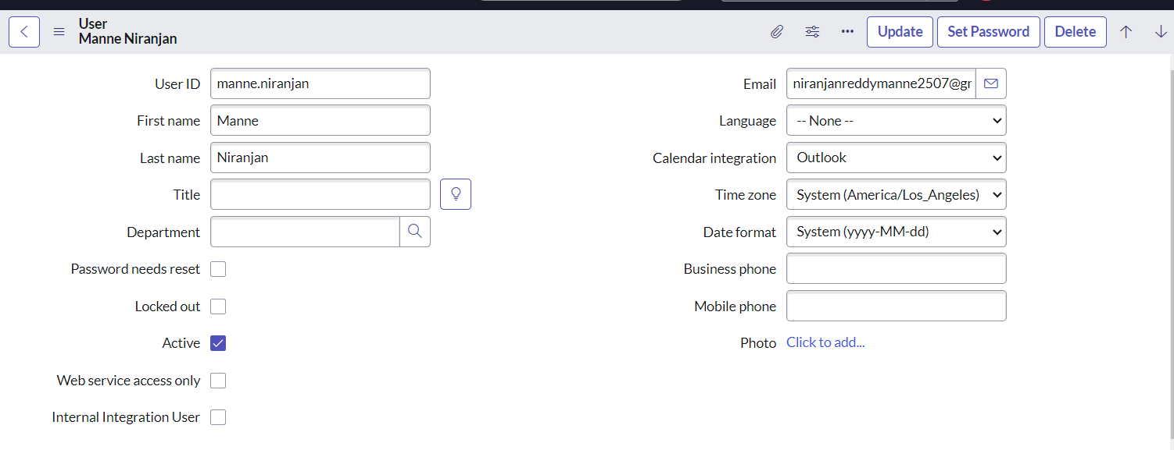
8. Then Click on submit to create the user.

**Activity 2: Create one more user**

1. The instructions given above are the same for creating another user.
2. Fill the following details given in the figure shown below to create another user.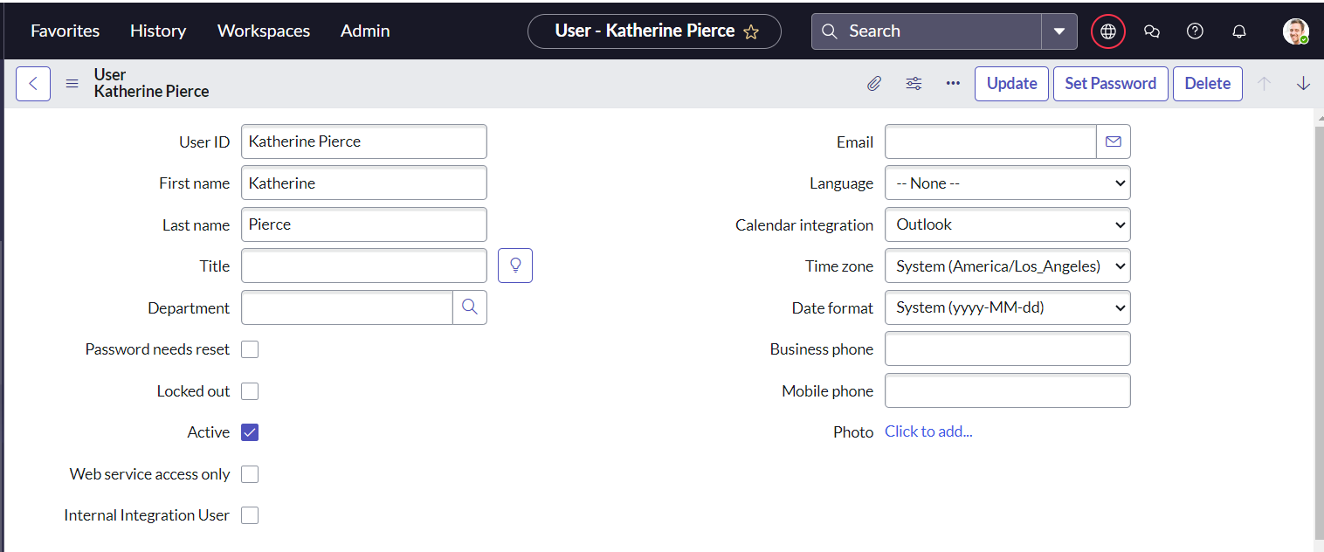
3. Then Click on submit to complete the creation.

**Milestone 2: Groups**

**Activity 1: Create Groups**

1. The first step is to Open service now.
2. Then Click on All menu option and search for groups in it.
3. Select groups which is present under system security.
4. Then Click on new option present in right top corner of the screen.
5. Fill the following details given in the figure to create a new group.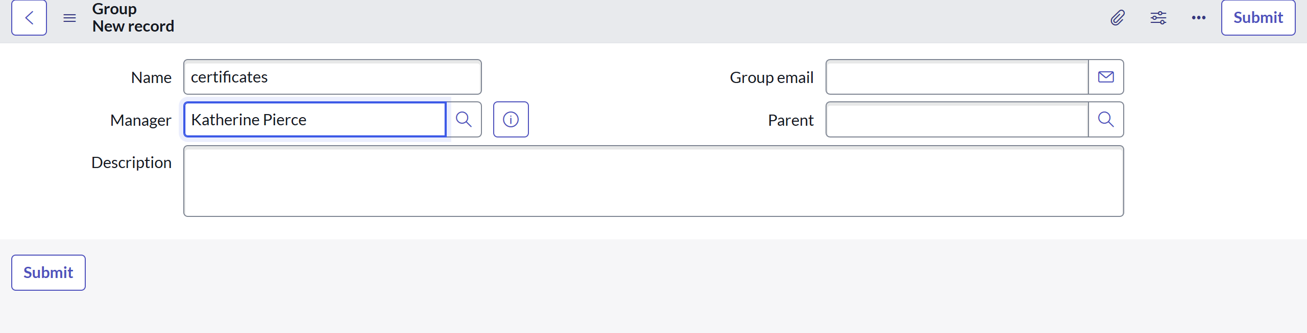
6. Finally Click on submit present in the top right cover of the screen.

**Activity 2: Create Another Group**

1. With the same instructions, Create another group with the following details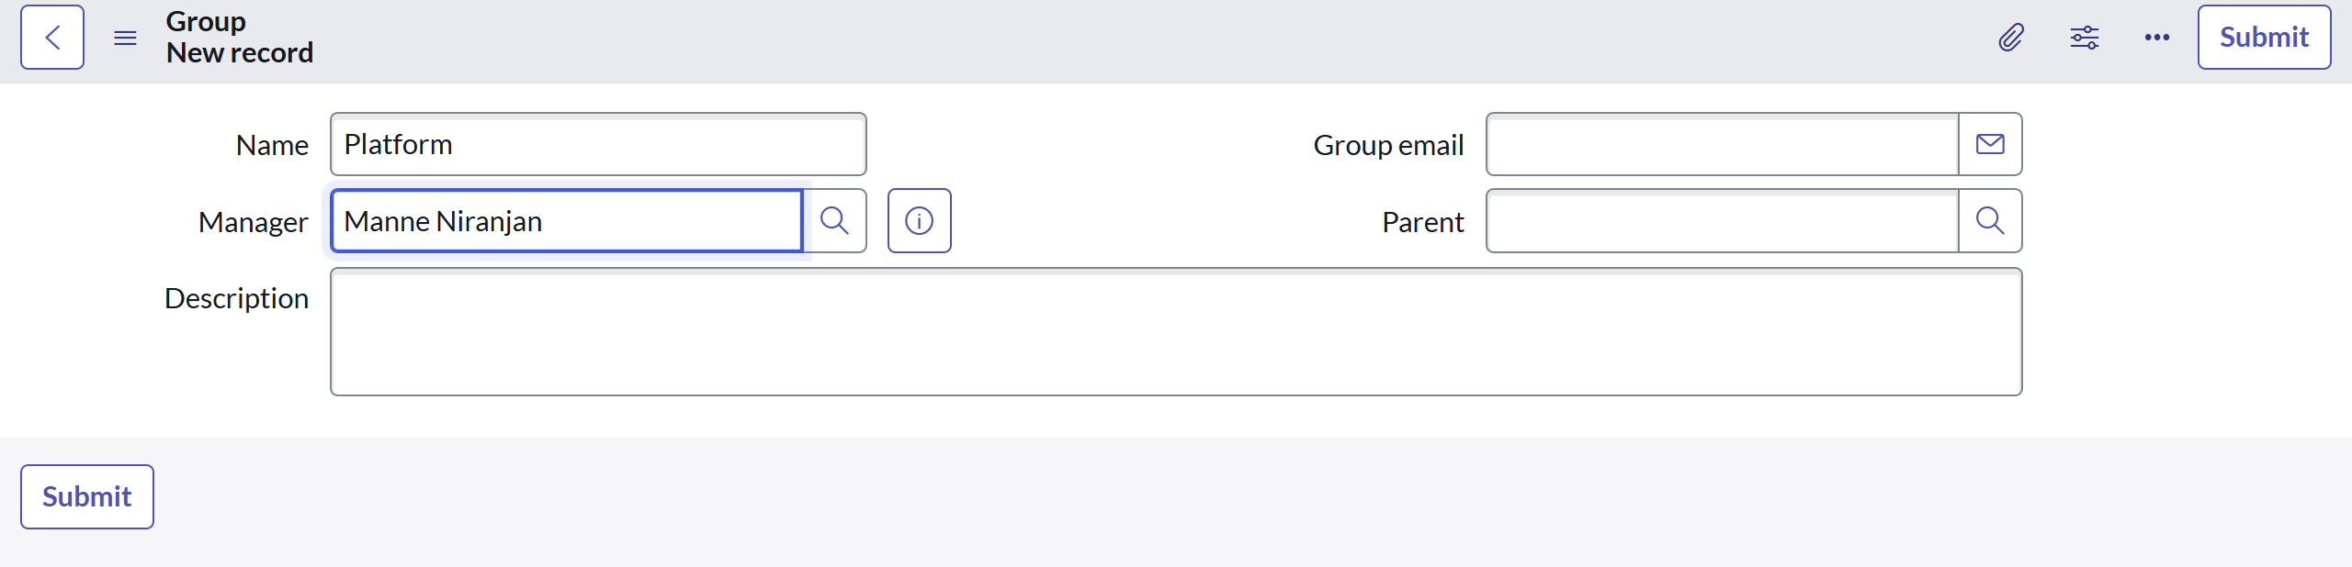
2. Then Click on submit to complete creating the group.

**Milestone 3: Roles**

**Activity 1: Create Roles**

1. The first step is to Open service now.
2. Then Click on All menu and search for roles in it.
3. Select roles which is present under system security.
4. In that page Click on new to open a new page to create role.
5. The using the figure given Fill the following details to create a new role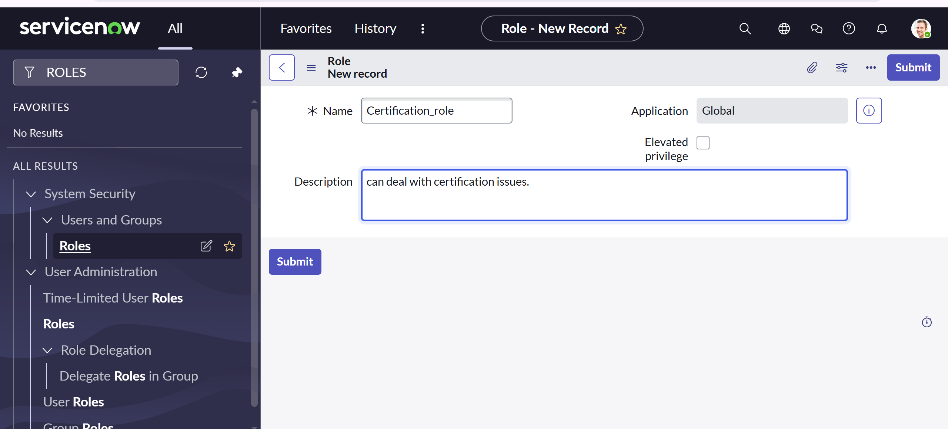
6. Then finally Click on submit to complete the process.

**Activity 2: Create another Roles**

1. To Create another role follow the same instruction to open new page.
2. The with the help of the figure, fill the details of the role to be created.  
     
     
   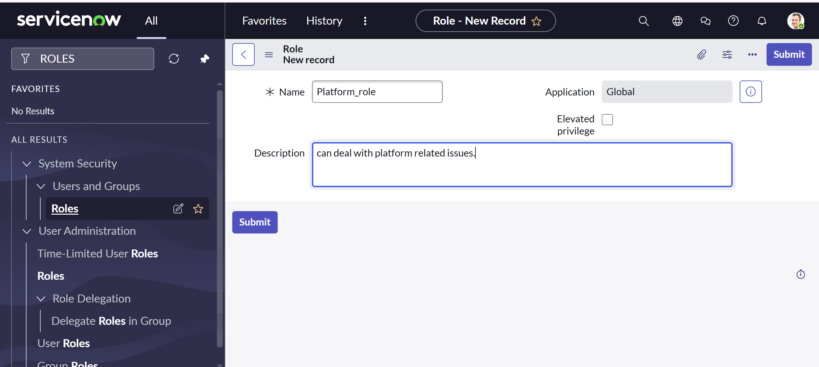
3. Then Click on submit to complete creating the role with name Platform_role

**Milestone 4: Table**

**Activity: Create Table**

1. First Open service now instances.
2. Then Click on All menu and search for tables in it.
3. In that Select tables which is present under system definition.
4. After opening tables, Click on new to create new table.
5. Fill the following details to create a new table.

* Label : Operations related
* Check the boxes Create module & Create mobile module
* Under new menu name : Operations related

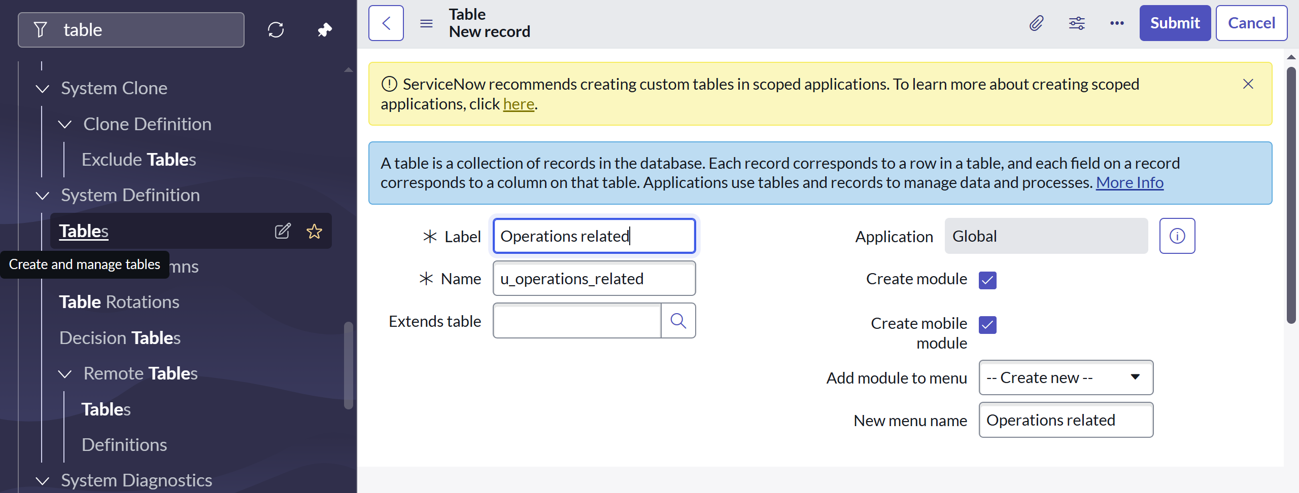

6. In the below we can see column option for the created table. Give columns as shown

in the figure below

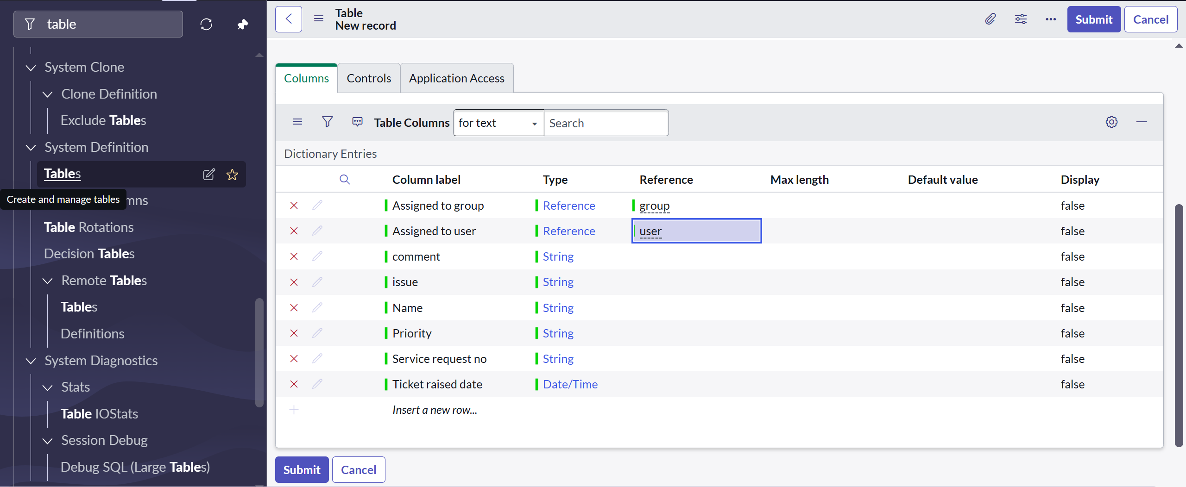

7. Click on submit to completecreating the table.

8. Create choices for the issue filed by using form design

Choices are:

* Unable to login to platform
* 404 error
* Regarding certificates
* Regarding user expired

**Milestone 5: Assign roles & users to groups**

**Activity 1: Assign roles & users to certificate group**

1. First Open service now Instance.
2. Then Click on All and search for groups in it.
3. Select groups which is present under system security.
4. There locates multiple groups from whih select the certificates group  
     
   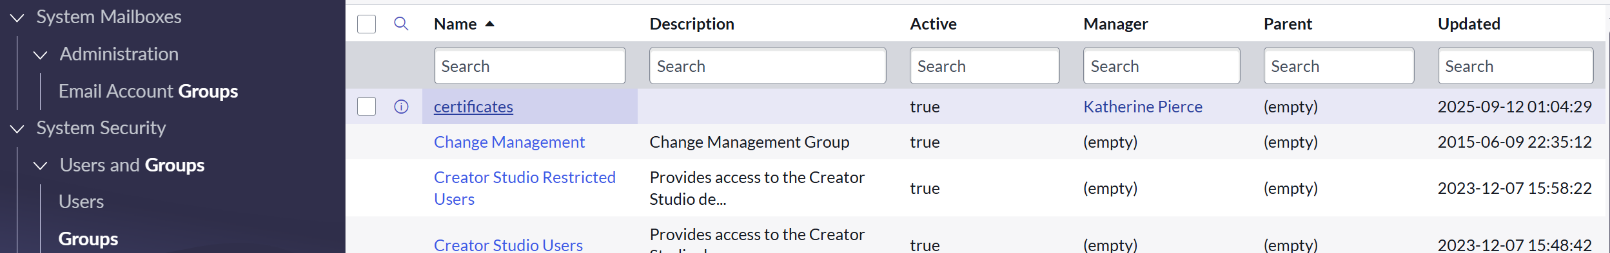
5. Under the group members we can see users names
6. In that Click on edit option present in right side.
7. From the collections Select Katherine Pierce and move it to certificates group and   
     
   Save.  
     
   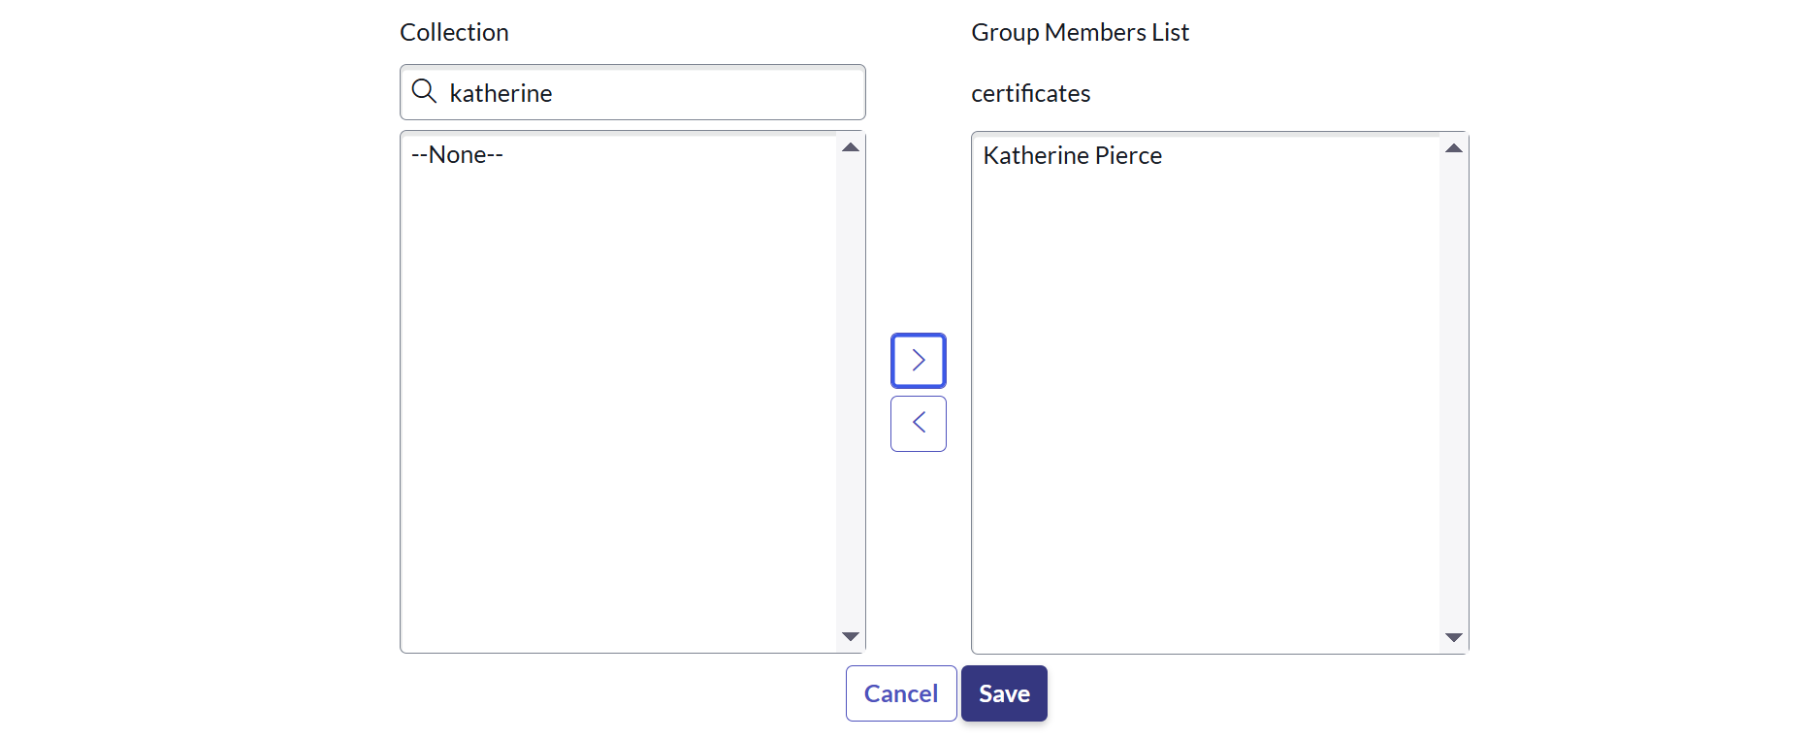
8. Then come back Click on roles present beside Group member.
9. Click on edit present in the rght side.
10. From the collections Select Certification_role and Save it in Role lists.

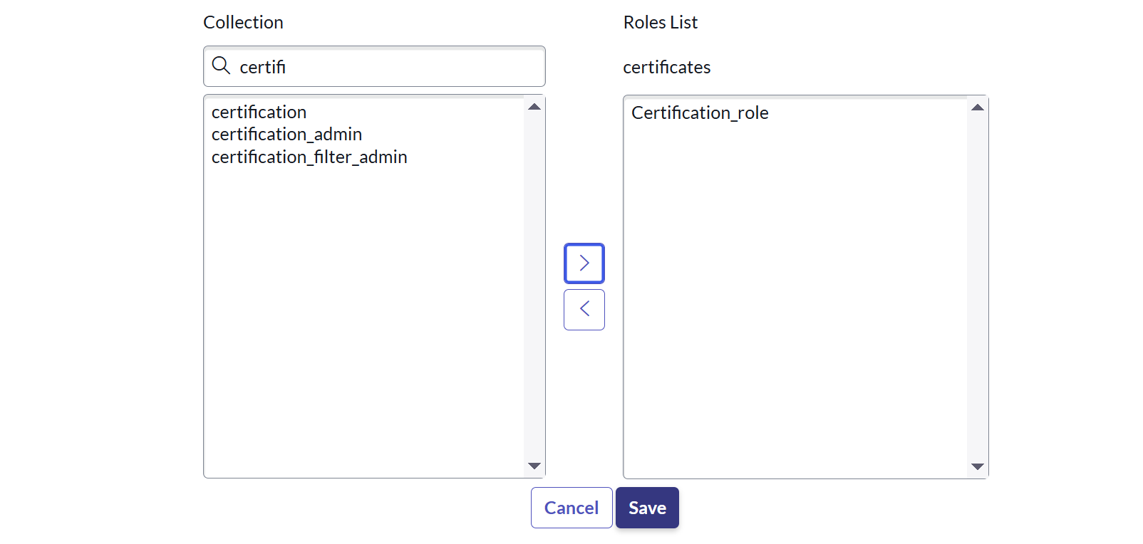

**Activity 2: Assign roles & users to platform group**

1. Folow the same instrution foe activity 2 as well.
2. Select the platform group
3. Under group members Click on edit
4. From which Select Manne Niranjan and save
5. Then Click on roles >> Click on edit option.
6. From which Select Platform_role and save

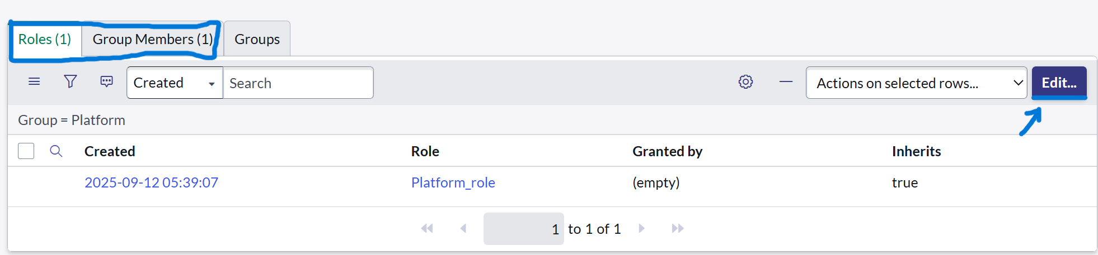

**Milestone 6: Assign role to table**

**Activity 1: Assign role to table**

1. First Open service now instance.
2. Then Click on All menu and search for operations related in it
3. Then Select Access control(ACL) present under system security.
4. In that Click on u_operations_related with read operation  
     
   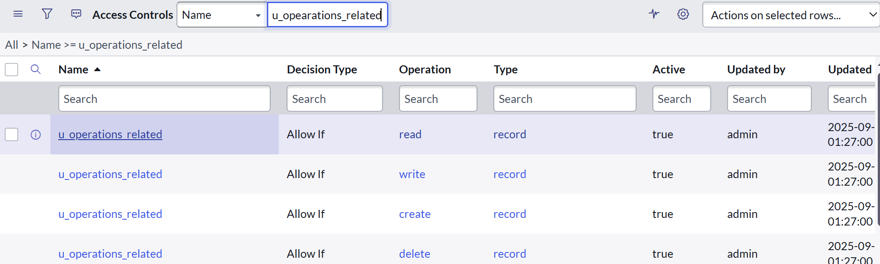
5. Click on the profile on top right side
6. Click on elevate role
7. Click on security admin and click on update
8. Under Requires role
9. Double click on insert a new row
10. Give platform role
11. And add certificate role
12. Click on update

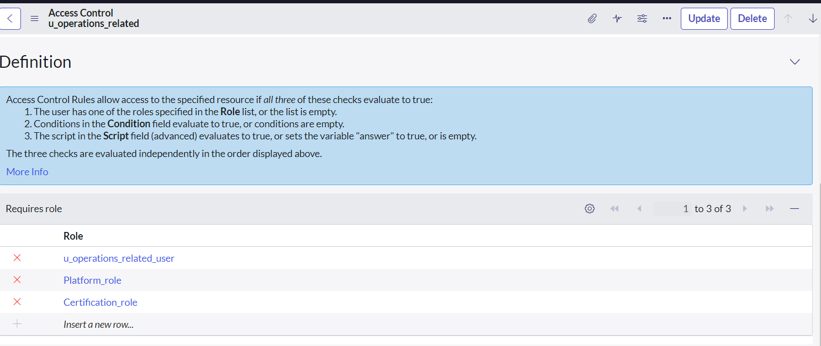

**Milestone 7: Create ACL**

**Activity 1: Create ACL**

1. Open service now.
2. Click on All >> search for ACL
3. Select Access Control(ACL) under system security
4. Click on new
5. Fill the following details to create a new ACL  
     
   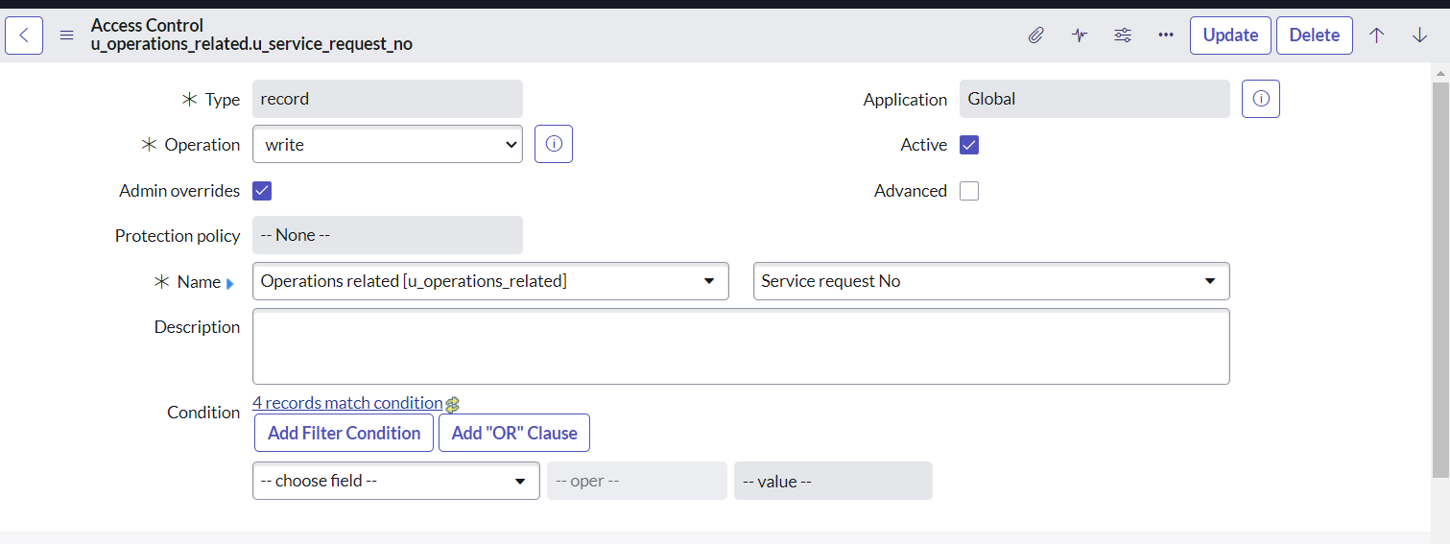
6. Scroll down under requires role
7. Double click on insert a new row
8. Give admin role
9. Click on submit
10. Similarly create 4 ACL for the following fields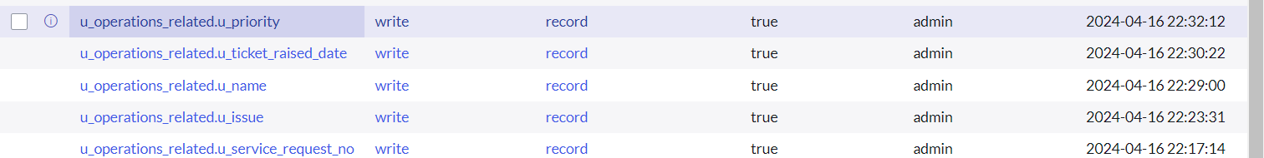
11. Create every fields with write operation and require roles as admin

**Milestone 8: Flow**

**Activity: Create a Flow to Assign operations ticket to group**

1. Open service now.
2. Click on All >> search for Flow Designer
3. Click on Flow Designer under Process Automation.  
     
   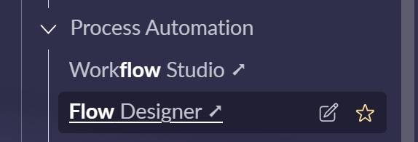
4. After opening Flow Designer Click on new and select Flow.
5. Under Flow properties Give Flow Name as “ Regarding Certificate”.
6. Application should be Global.
7. Select Run user as “ System user ” from that choice.
8. Click on Submit.  
     
   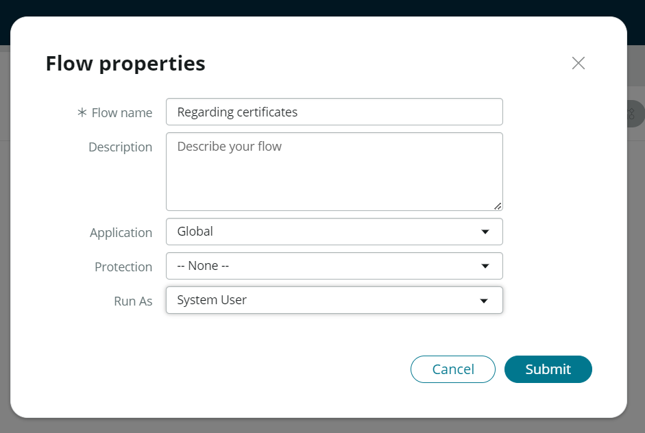
9. After creating the flow, Click on Add a trigger
10. Select the trigger in that Search for “create or update a record” and select that.
11. Give the table name as “ Operations related ”.
12. Give the Condition as  
    Field : issue  
    Operator : is  
    Value : Regrading Certificates  
      
    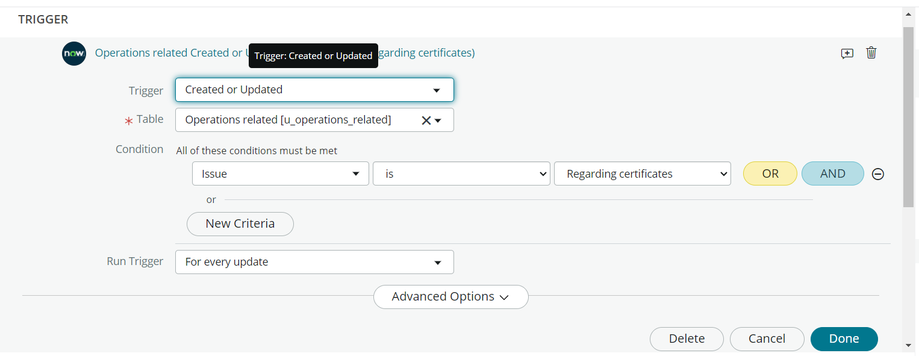
13. After that click on Done.
14. Now under Actions.
15. Click on Add an action.
16. Select action in that search for “ Update Record ”.
17. In Record field drag the fields from the data navigation from left side
18. Table will be auto assigned after that
19. Give the field as “ Assigned to group ”
20. Give value as “ Certificates ”  
      
    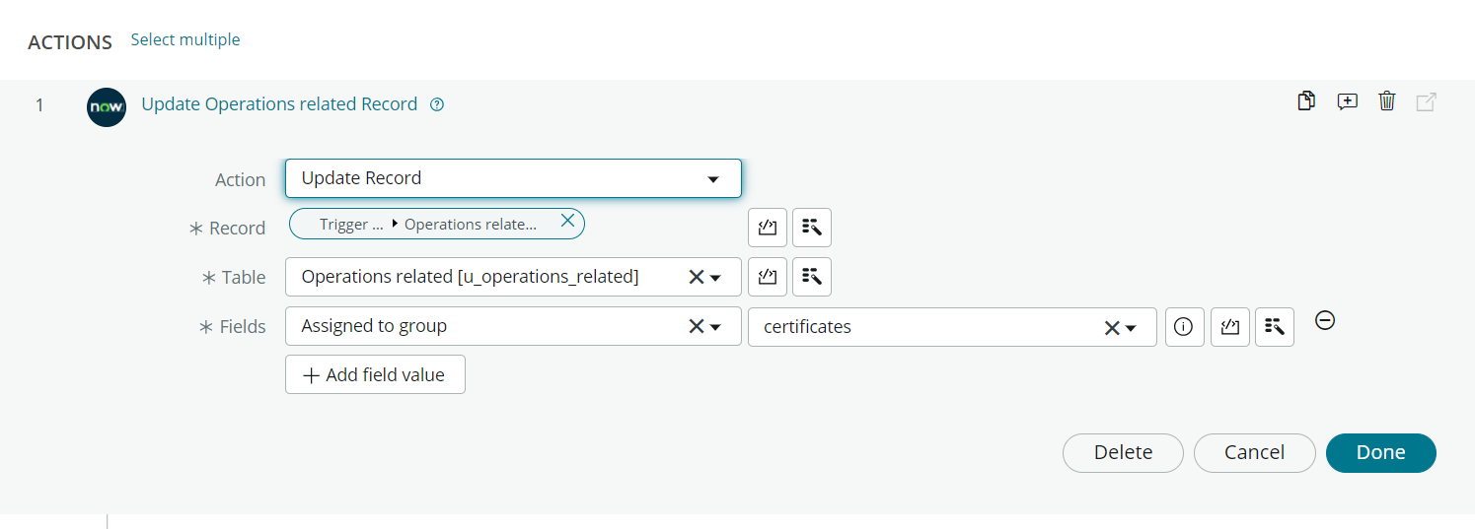
21. Click on Done.  
      
    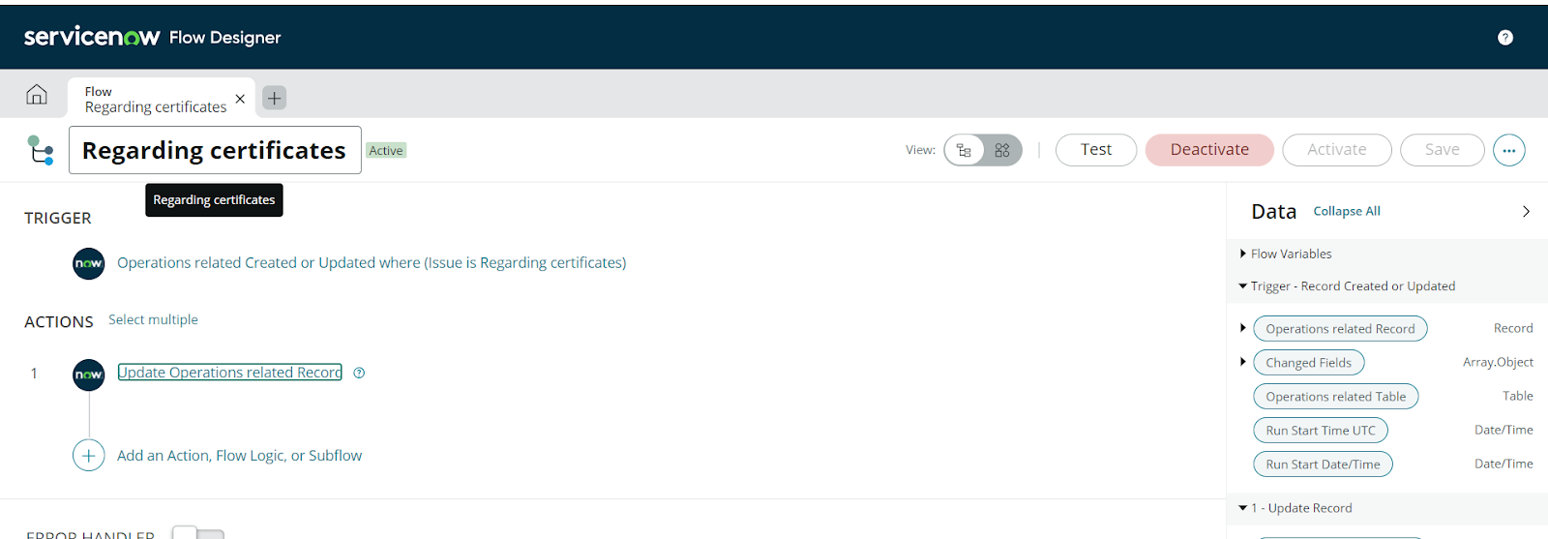
22. Click on Save present in top right corner to save the Flow.
23. Then Click on Activate.

**Activity 2: Create a Flow to Assign operations ticket to Platform group**

1. Open service now.
2. Click on All >> search for Flow Designer
3. Click on Flow Designer under Process Automation.
4. After opening Flow Designer Click on new and select Flow.
5. Under Flow properties Give Flow Name as “ Regarding Platform ”.
6. Application should be Global.
7. Select Run user as “ System user ” from that choice.  
     
   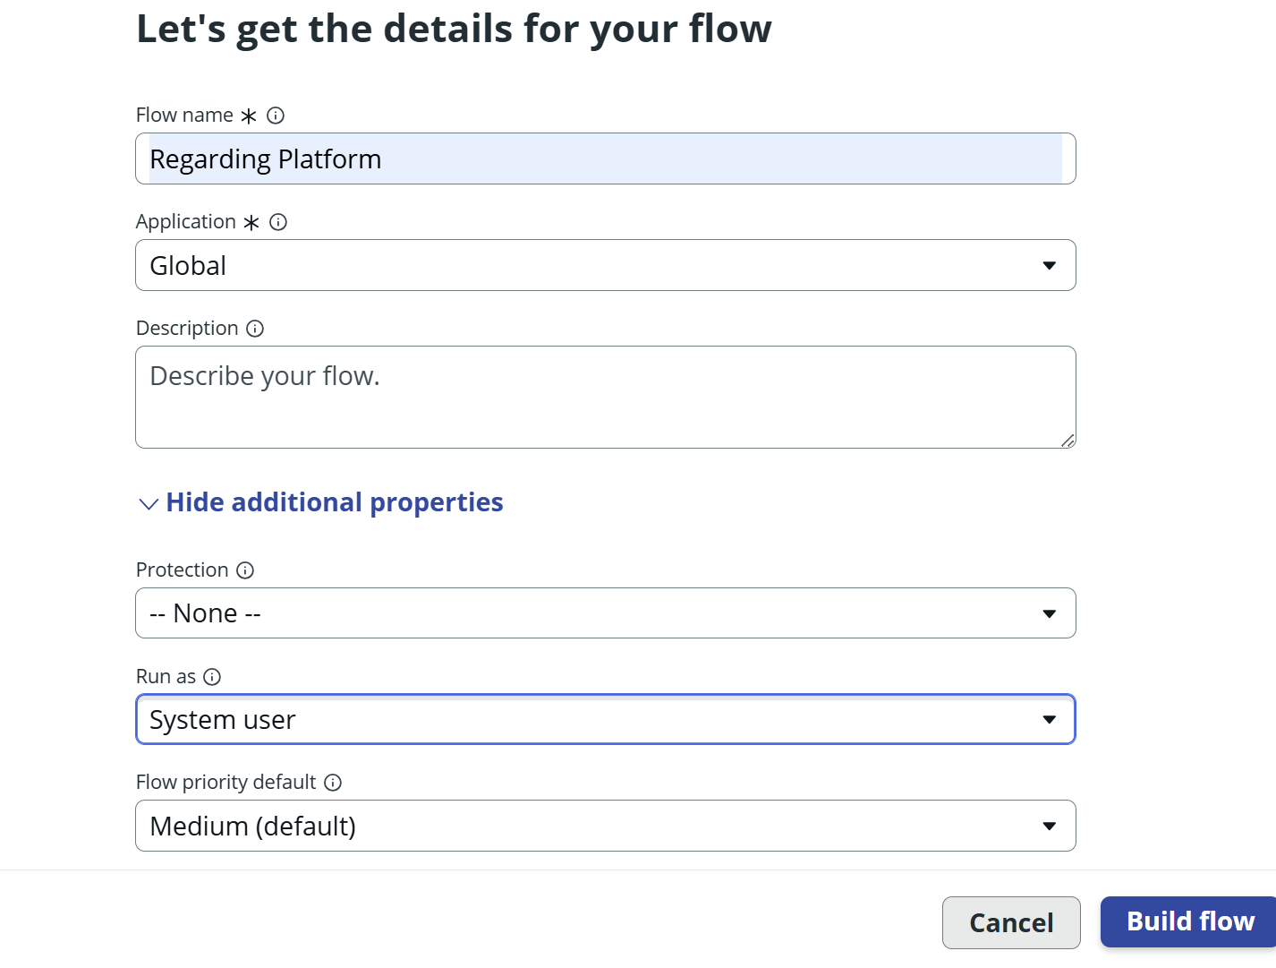
8. Click on Submit.
9. Click on Add a trigger
10. Select the trigger in that Search for “create or update a record” and select that.
11. Give the table name as “ Operations related ”.
12. Give the Condition as  
     Field : issue  
     Operator : is  
     Value : Unable to login to platform
13. Click on New Criteria  
     Field : issue  
     Operator : is  
     Value : 404 Error
14. Click on New Criteria  
     Field : issue  
     Operator : is  
     Value : Regrading User expired   
      
    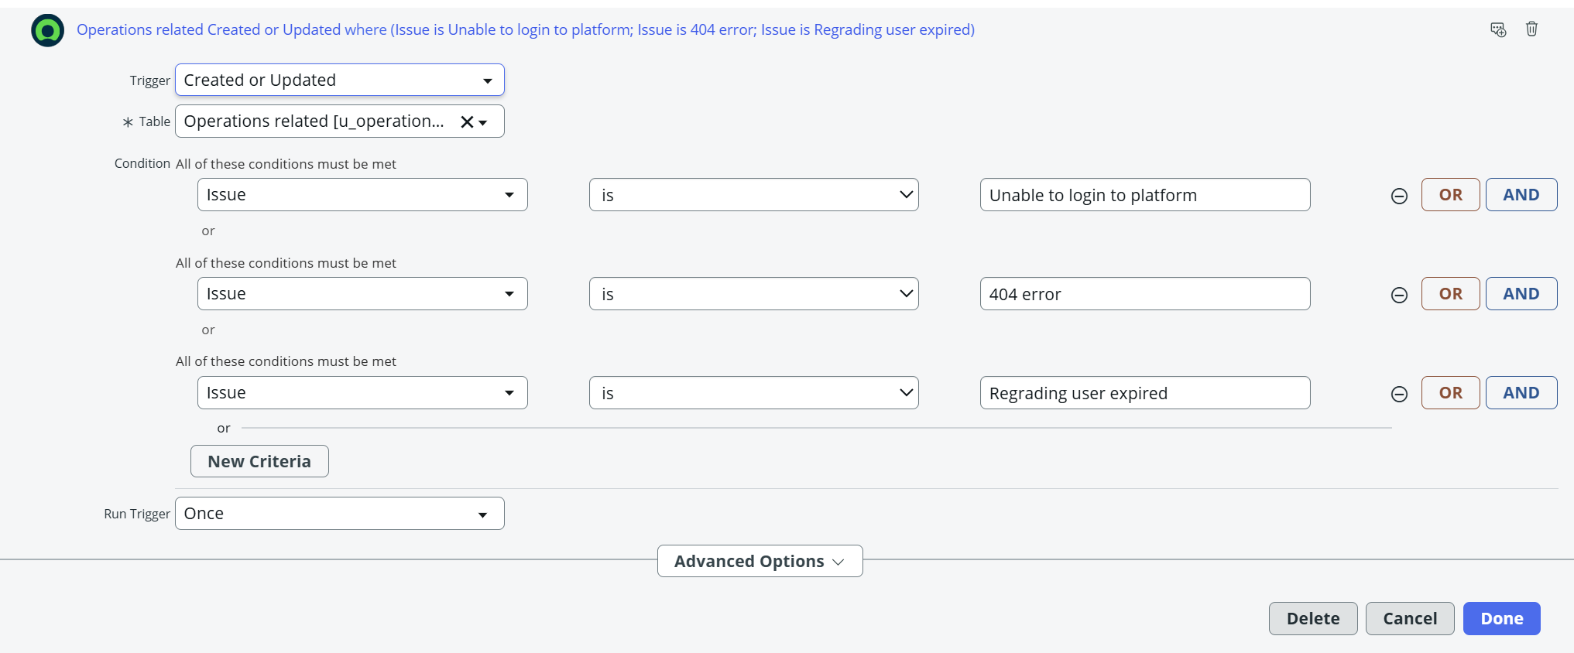
15. After that click on Done.
16. Now under Actions.
17. Click on Add an action.
18. Select action in that search for “ Update Record ”.
19. In Record field drag the fields from the data navigation from left side
20. Table will be auto assigned after that
21. Give the field as “ Assigned to group ”.
22. Give value as “ Platform ”.  
      
    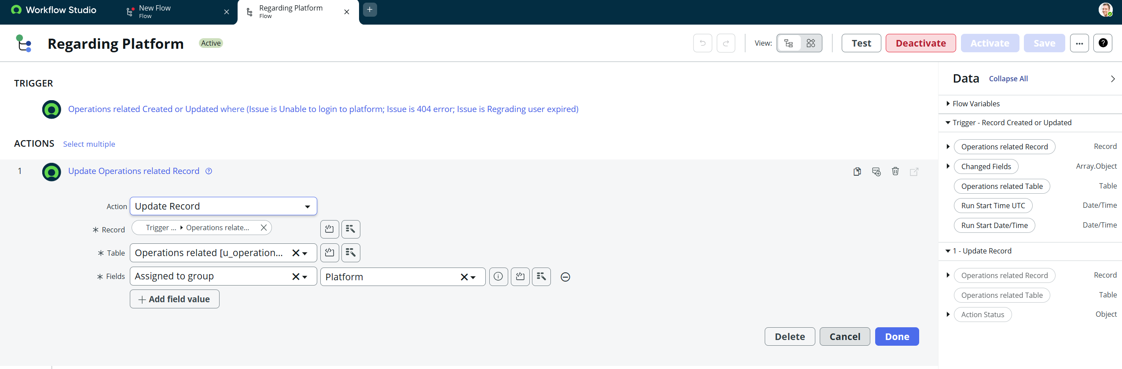
23. Click on Done.
24. Click on Save to save the Flow.
25. Click on Activate.

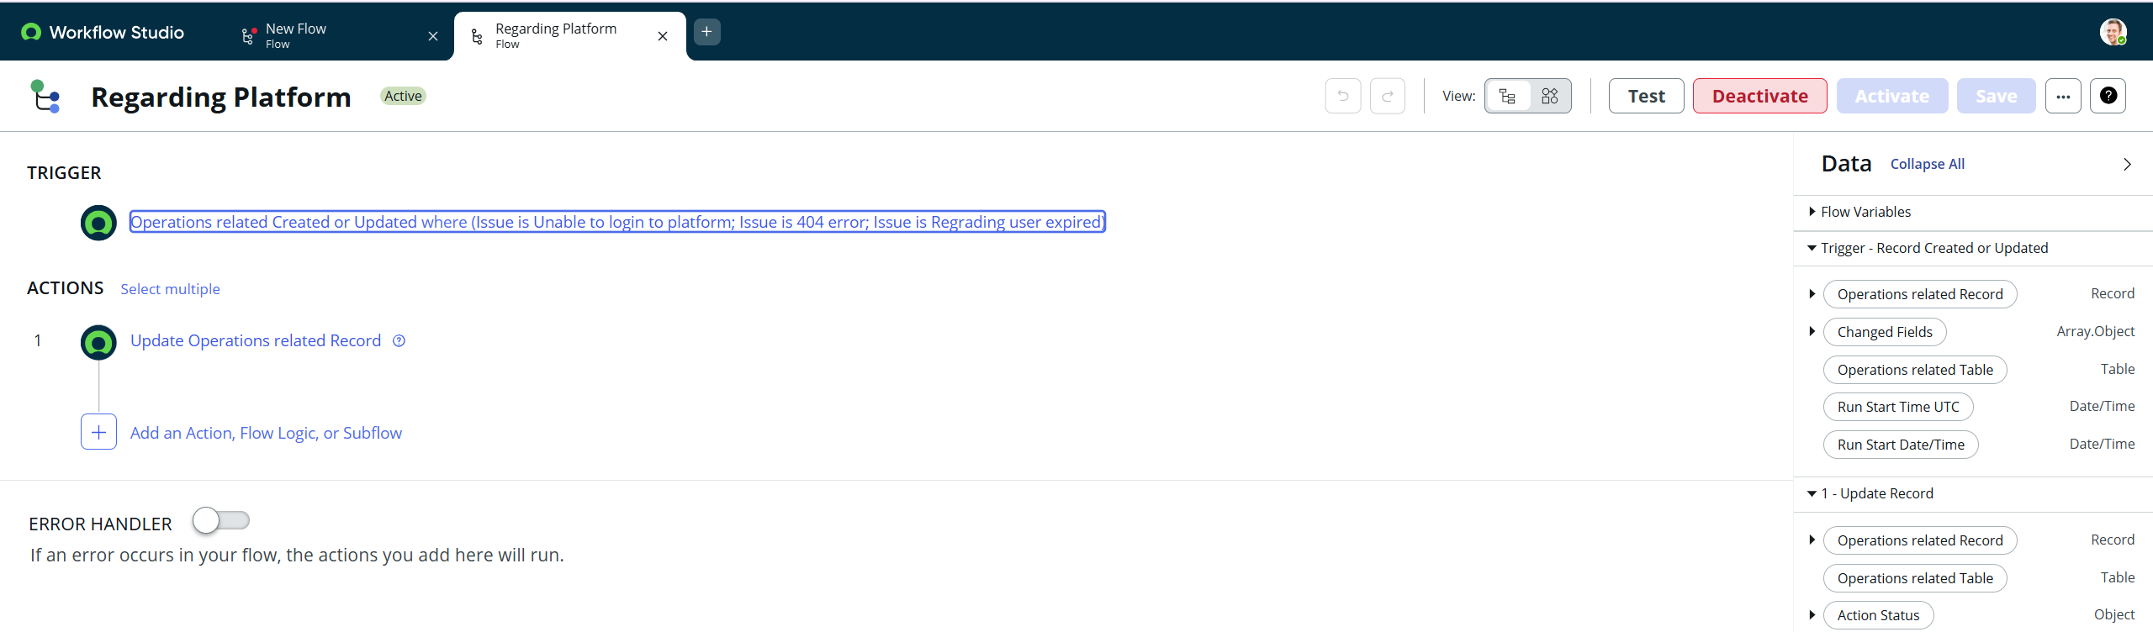

**CONCLUSION:**

In conclusion, The implementation of the automated ticket routing system at ABC Corporation has been a significant success. By leveraging the capabilities of ServiceNow, we have streamlined the process of assigning support tickets to the appropriate teams, addressing the challenges of manual routing, and ensuring timely resolution of issues.